EMERGENCY ACTION PLAN FOR FRIENDSWOOD JUNIOR HIGH ATHLETICS

Introduction

Emergency situations may arise at any time during athletic events. Expedient action must be taken in order to provide the best possible care to the sport participant’s emergency and/or life-threatening conditions. The development and implementation of an emergency plan will help ensure that the best care will be provided.

As emergencies may occur at any time and during any activity, all school employees and sports medicine teams must be prepared. This preparation involves formulation of an emergency plan, proper coverage of events, maintenance of appropriate emergency equipment and supplies, utilization of appropriate emergency medical personnel, and continuing education in the area of emergency medicine and planning. Through careful pre-participation physical screenings, adequate medical coverage, safe practice and training techniques, and other safety avenues, some potential emergencies may be averted. However, accidents and injuries are inherent with sports participation, and proper preparation on the part of the sports medicine team should enable each emergency situation to be managed appropriately.

Components of the Emergency Plan

These are the basic components of every emergency action plan for athletics:

1. Emergency Personnel
2. Emergency Communication
3. Emergency Equipment
4. Roles of Licensed Athletic Trainers, Student Trainers, Coaches, and Administrators
5. Venue Directions

Emergency Plan Personnel

With athletic practice and competition, the first responder to an emergency situation is typically a member of the athletic staff, most commonly a coach or licensed athletic trainer. The type and degree of sports medicine coverage for an athletic event may vary widely based on such factors as the sport or activity, the setting, and the type of training or competition. Certification in cardiopulmonary resuscitation (CPR), athletic safety, prevention of disease transmission, and emergency plan review is required annually for all athletics personnel associated with practices, competitions, skills instruction, and strength and conditioning.

The development of an emergency plan cannot be complete without the formation of an emergency team. The emergency team may consist of a number of healthcare providers including physicians, emergency medical technicians, licensed athletic trainers, student athletic trainers, coaches, parents, and, possibly other athletes and bystanders. When forming the emergency team, it is important to adapt the team to each situation or sport. It may also be advantageous to have more than one individual assigned to each role. This allows the emergency team to function even though certain members may not always be present. The roles of these individuals within the emergency team may vary depending on various factors such as the number of members of the team, the athletic venue itself, or the preference of the head coach or head athletic trainer.

Roles within the Emergency Team
1. Establish scene safety and immediate care of the athlete
2. Activation of the Emergency Medical System
3. Emergency equipment retrieval
4. Direction of EMS to scene

There are four basic roles within the emergency team. The first and most important role is establishing safety of the scene and immediate care of the athlete. Acute care in an emergency situation should be provided by the most qualified individual on the scene. In instances that a licensed athletic trainer is available, this role will be assumed by the licensed athletic trainer.
The second role, EMS activation, may be necessary in situations where emergency transportation is not already present at the sporting event. This should be done as soon as the situation is deemed an emergency or a life-threatening event. Time is the most critical factor under emergency conditions. Activating the EMS system may be done by anyone on the team. However, the person chosen for this duty should be someone who is calm under pressure and who communicates well over the telephone. This person should also be familiar with the location and address of the sporting event.

EMS Activation
Making the Call:
- 911
- Landline Phone 9911
Provide Information:
- Name, address, telephone number of caller
- Nature of emergency
- Number of athletes
- Condition of athlete (s)
- First Aid treatment initiated
- Specific directions as needed to locate the emergency scene
(ie. “Faculty parking lot near Main Street”)
- Other information as requested by dispatcher

The third role, equipment retrieval may be done by anyone on the emergency team who is familiar with the types and location of the specific equipment needed. Student athletic trainers, coaches, and athletes are good choices for this role.

The fourth role of the emergency team is that of directing EMS to the scene. One member of the team should be responsible for meeting emergency medical personnel as they arrive at the site of the emergency. Depending on ease of access, this person should have keys to any locked gates or doors that may slow the arrival of medical personnel. A student athletic trainer, administrator, athlete, or coach may be appropriate for this role.

Emergency Communication

Communication is the key to quick emergency response. Athletic trainers and emergency medical personnel must work together to provide the best emergency response capability and should have contact information established as a part of pre-planning for emergency situations. Communication prior to the event is a good way to establish boundaries and to build rapport between both groups of professionals. If emergency medical transportation is not available on the site during a particular sporting event then direct communication with the emergency medical system at the time of injury or illness is necessary.
Access to a working telephone or other telecommunications device, whether fixed or mobile, should be assured. The communications system should be checked prior to each practice or competition to ensure proper working order. A back-up communication plan should be in effect should there be failure of the primary communication system. The most common method of communication is a public telephone. However, a cellular phone is preferred if available. At any athletic venue, whether home or away, it is important to know the location of a workable telephone. Pre-arranged access to the phone should be established if it is not easily accessible.

Emergency Equipment

All necessary emergency equipment should be at the site and quickly accessible. Personnel should be familiar with the function and operation of each type of emergency equipment. Equipment should be in good operating condition and personnel must be trained in advance to use it properly. Emergency equipment should be checked on a regular basis and its use rehearsed by emergency personnel. The emergency equipment available should be appropriate for the level of training for the emergency medical providers. Creating an equipment inspection log book for continued inspection is strongly recommended.
It is important to know the proper way to care for and store the equipment as well. Equipment should be stored in a clean and environmentally controlled area. It should be readily available when emergency situations arise.

Medical Emergency Transportation

Emphasis should be placed at having an ambulance on site at high risk sporting events. In the event that an ambulance is on site, there should be a designated location with rapid access to the site and a cleared route for entering/exiting the venue. If an ambulance is not present at an event, entrance to the facility should be clearly marked and accessible. In the event of an emergency, the 911 system will still be utilized for activating emergency transport.

In the medical emergency evaluation, the primary survey assists the emergency care provider in identifying emergencies requiring critical intervention and in determining transport decisions. In an emergency situation, the athlete should be transported by ambulance, where the necessary staff and equipment is available to deliver appropriate care. Emergency care providers should refrain from transporting unstable athletes in inappropriate vehicles. Care must be taken to ensure that the activity areas are supervised should the emergency care provider leave the site in transporting the athlete. Emergency situations where there is impairment in level of consciousness (LOC), airway, breathing, circulation (ABC), or neurovascular compromise should be considered “load and go” situations and emphasis is placed on rapid evaluation, treatment and transportation.

Non-Medical Emergencies

For the following non-medical emergencies: fire, bomb threats, severe weather and violent or criminal behavior, refer to the school district’s emergency action plan.

Safety Drill

All Friendswood Independent School District athletic teams need to review this emergency action plan at the start of each semester.

Conclusion

The importance of being properly prepared when athletic emergencies arise cannot be stressed enough. An athlete’s survival may hinge on how well trained and prepared athletic healthcare providers are. It is prudent to invest athletic department “ownership" in the emergency plan by involving the athletic administration and sport coaches as well as sports medicine personnel. The emergency plan should be reviewed at least once a year with all athletic personnel. Through development and implementation of the emergency plan, the Friendswood Independent School District helps ensure that the athlete will have the best care provided when an emergency situation does arise.

Examples of Urgent Injuries

Obvious deformity (broken bone or dislocated joint), has not lost consciousness and the scene is safe (the athlete is not in danger--in traffic/lightning/etc.) Call EMS immediately. Contact the Parents and the Athletic Training Staff. Do not attempt to reduce or relocate any deformity.

Friendswood Junior High School Emergency Procedure
All Fields, Track and Tennis Courts

Urgent
1. Call 911
Cell phone dial 911
Campus landline phone dial 911

2. Instruct EMS to report to:
Friendswood Junior High School
1000 Manison
Friendswood, TX 77546
Instruct EMS to report to the field you are located on

3. Send appropriate personnel to unlock the gates and meet and direct EMS personnel onto the field from the parking lot.

4. Provide necessary information to EMS personnel.

5. Provide appropriate emergency care until the arrival of EMS personnel.
The authority to administer first aid or emergency treatment should be delegated to:
1st - Attending Team Physician if present
2nd - Adult Staff Athletic Trainer if present
3rd – Coach in charge of team (All coaches are required to be CPR/AED/FIRST AID certified)
4th – Assistance from a student athletic trainer under the supervision of a staff athletic trainer or coach
**At no time should a fan or spectator be allowed to render treatment to an athlete that they are not the parent or legal guardian of.

6. Contact Parent
If an athlete requires transportation to a local hospital and the parents are not available or present:
A responsible school official should accompany the athlete to the hospital.
The athlete’s Consent Card should be sent with the athlete.

7. Contact Athletic Trainer
Call in the order listed, if no answer leave a message and call the next one
HPH Contract AT- Marilyn Rodriguez-(832)-515-4108
Blake Lapier-(979)-583-3168
Tevin Dent- (832)-314-9521
Melisa Jack-(281)-841-1292

8. Contact Athletic Director-Robert Koopmann

LOCATION(s) OF AED
- Athletic training room
- Athletics hallway

Friendswood Junior High Emergency Procedure
Athletic Training Room, Weight Room, Gyms

Urgent
1. Call 911
Cell phone dial 911
Campus landline phone dial 911

2. Instruct EMS to report to:
Friendswood Junior High School
1000 Manison
Friendswood, TX 77546
Instruct EMS to enter the facility by turning onto the bus loop from Falcon Ridge and enter door #1 of the Athletics Hallway
Athletic training room - on the right passed the restrooms
Weight room - enter the second gym door, go through the gym second door on the right
Boy’s gym - first door on the left
Girl’s gym- second door on the left

3. Send appropriate personnel to unlock the gates and meet and direct EMS personnel to the scene.

4. Provide necessary information to EMS personnel.

5. Provide appropriate emergency care until the arrival of EMS personnel.
The authority to administer first aid or emergency treatment should be delegated to:
1st - Attending Team Physician if present
2nd - Adult Staff Athletic Trainer if present
3rd – Coach in charge of team (All coaches are required to be CPR/AED/FIRST AID certified)
4th – Assistance from student athletic trainer under the supervision of a staff athletic trainer or coach
**At no time should a fan or spectator be allowed to render treatment to an athlete that they are not the parent or legal guardian of.

6. Contact Parent
If an athlete requires transportation to a local hospital and the parents are not available or present:
A responsible school official should accompany the athlete to the hospital.
The athlete’s Consent Card should be sent with the athlete.

7. Contact Athletic Trainer
Call in the order listed, if no answer leave a message and call the next one
HPH Contract AT-Marilyn Rodriguez:(832)-515-4108
Blake Lapier:(979)-583-3168
Tevin Dent:(832)-314-9521
Melissa Jack:(281)-841-1292

8. Contact Athletic Director- Robert Kooppmann

LOCATION(s) OF AED
1. Athletic training room
2. Athletics Hallway (Next to Girls Gym)

FRIENDSWOOD JUNIOR HIGH VENUE MAP

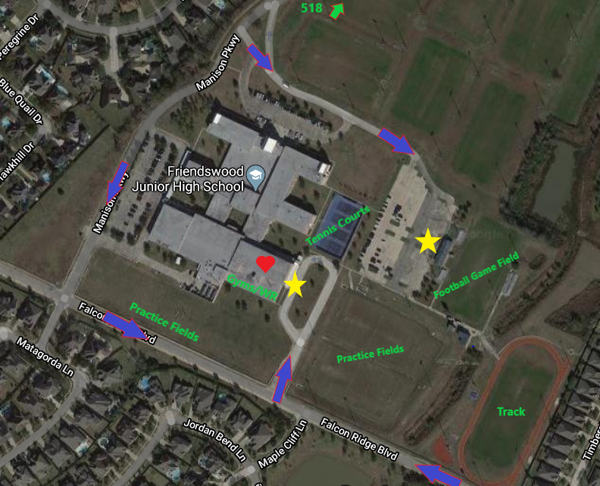

Legend:
Gold Star = Ambulance/EMS team parking location
Blue Arrows = Guide to venue for EMS
Heart = AED Location

